Dessa Shapiro Gen Z photo and artist statement

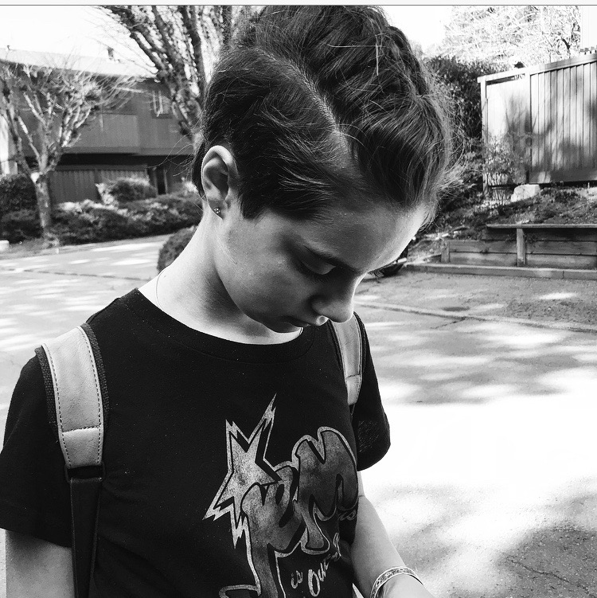

For the past years of generation Z, there have been increased suicide rates around the world. A lot of adults from other generations that think the teens of Generation Z are more fragile and therefore have made a stereotype of our generation. This photo shows an insecure girl in the dark. A lot of people in our generation are a kind of “experiment” for new types of things. There are a lot of different aspects that contribute to the different emotional factors of teens today. In today's time's teens have access to new technology and that comes with social media. With social media comes consequences, now there are cyberbullies. Cyberbullying is a big problem because when a person is online they can hide their identity from others and can wear a “mask” so they feel free to say things that they would never say to a person's face. Cyberbullying is not the only aspect that contributes to increased suicide rates. There is also more pressure when it comes to body image. There are a lot of expectations of what a perfect girl or boy would look like and what they would wear and how they compose themselves. Another thing would be all the judgment of other teens today. A lot of teens have become somewhat “brainwashed” by the idealism of our society. So I think that that the stereotype that our generation is more fragile wrong because we are in an experimental phase. And we are under a lot more pressure then a lot of other generations were. And we deserve to be appreciated and not looked down upon because we are very different from everybody else.